
School of Engineering & Technology
T.Y. B. Tech. CSE(AI&DS)
Course: Data Communication And Computer Networking
Report On:
Campus Network Design And Implementation Using EIGRP And DHCP
Submitted by:
Sakshi Bodke
Sakshi Chidre
Tejas Shinde
Yash Shinde

Under the Guidance of:
Dr. Manisha Khadse

Year: 2025- 2026

CAMPUS NETWORK DESIGN AND IMPLEMENTATION USING EIGRP AND DHCP
Problem Statement:
Problem Statement
Educational institutions face significant challenges in establishing efficient network infrastructure that can support multiple departments, buildings, and services. Traditional static IP configuration becomes unmanageable in large-scale deployments, leading to configuration errors, IP conflicts, and administrative overhead. Additionally, without dynamic routing protocols, network administrators must manually configure routes, making the network inflexible and difficult to scale.
Objectives:
- To design an efficient and scalable campus network connecting multiple departments.
- To implement centralized IP address management using a single DHCP server.
- To configure EIGRP (Enhanced Interior Gateway Routing Protocol) for dynamic routing between routers.
- To enable seamless inter-department communication and data sharing.
- To provide essential network services such as DNS, Web, and FTP servers.
- To ensure reliability, reduced network traffic, and fast convergence in the campus network.
Scope:
- The project covers the design and implementation of a LAN-based campus network with inter-building connectivity.
- It involves setting up three routers, multiple departmental switches, and end devices (PCs, printers, laptops).
- The implementation ensures IP allocation using DHCP, name resolution using DNS, and data communication via EIGRP routing.
- The network simulates real-world institutional setups including buildings like A,B, Internet Lab, Admin, and PVC Cabin.
- The project aims to serve as a model for future scalability and real deployment.
Design & Topology Diagram:

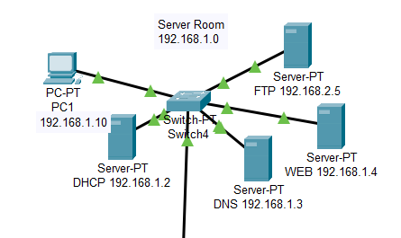
DEPARTMENT | COMPONENT | IP ADDRESS | DEFAULT GATEWAY | DNS SERVER | PRINTER  QUANTITY
SERVER ROOM  (192.168.1.0) | DHCP SERVER | 192.168.1.2 | 192.168.1.1 | 192.168.1.3 | -
SERVER ROOM  (192.168.1.0) | DNS SERVER | 192.168.1.3 | 192.168.1.1 | 192.168.1.3 | -
SERVER ROOM  (192.168.1.0) | WEB SERVER | 192.168.1.4 | 192.168.1.1 | 192.168.1.3 | -
SERVER ROOM  (192.168.1.0) | FTP SERVER | 192.168.1.5 | 192.168.1.1 | 192.168.1.3 | -
SERVER ROOM  (192.168.1.0) | PC1 | 192.168.1.10 | 192.168.1.1 | 192.168.1.3 | -

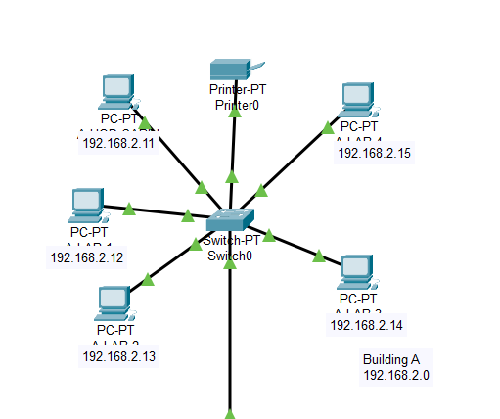
DEPARTMENT | COMPONENT | IP ADDRESS | DEFAULT GATEWAY | DNS SERVER | Printer  QUANTITY
Building A  (192.168.2.0) | A- HOD CABIN | 192.168.2.11 | 192.168.2.1 | 192.168.1.3 | 1
Building A  (192.168.2.0) | A- LAB 1 | 192.168.2.12 | 192.168.2.1 | 192.168.1.3 | 1
Building A  (192.168.2.0) | A- LAB 2 | 192.168.2.13 | 192.168.2.1 | 192.168.1.3 | 1
Building A  (192.168.2.0) | A- LAB 3 | 192.168.2.14 | 192.168.2.1 | 192.168.1.3 | 1
Building A  (192.168.2.0) | A- LAB 4 | 192.168.2.15 | 192.168.2.1 | 192.168.1.3 | 1

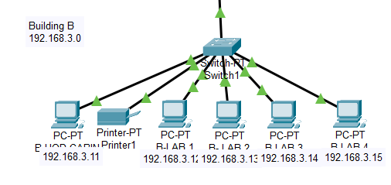
DEPARTMENT | COMPONENT | IP ADDRESS | DEFAULT GATEWAY | DNS SERVER | PRINTER  QUANTITY
Building B  (192.168.3.0) | B- HOD CABIN | 192.168.3.11 | 192.168.3.1 | 192.168.1.3 | 1
Building B  (192.168.3.0) | B- LAB 1 | 192.168.3.12 | 192.168.3.1 | 192.168.1.3 | 1
Building B  (192.168.3.0) | B- LAB 2 | 192.168.3.13 | 192.168.3.1 | 192.168.1.3 | 1
Building B  (192.168.3.0) | B- LAB 3 | 192.168.3.14 | 192.168.3.1 | 192.168.1.3 | 1
Building B  (192.168.3.0) | B- LAB 4 | 192.168.3.15 | 192.168.3.1 | 192.168.1.3 | 1
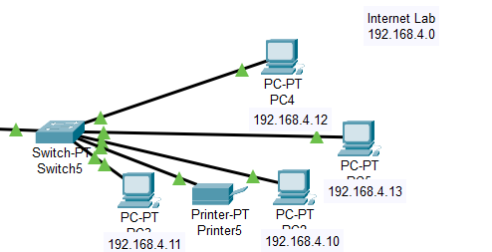

DEPARTMENT | COMPONENT | IP ADDRESS | DEFAULT GATEWAY | DNS SERVER | PRINTER  QUANTITY
Internet Lab (192.168.4.0) | PC2 | 192.168.4.10 | 192.168.4.1 | 192.168.1.3 | 1
Internet Lab (192.168.4.0) | PC3 | 192.168.4.11 | 192.168.4.1 | 192.168.1.3 | 1
Internet Lab (192.168.4.0) | PC4 | 192.168.4.12 | 192.168.4.1 | 192.168.1.3 | 1
Internet Lab (192.168.4.0) | PC5 | 192.168.4.13 | 192.168.4.1 | 192.168.1.3 | 1

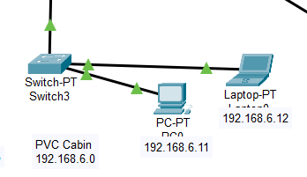
DEPARTMENT | COMPONENT | IP ADDRESS | DEFAULT GATEWAY | DNS SERVER | PRINTER  QUANTITY
PVC Cabin (192.168.6.0) | PC 0 | 192.168.6.11 | 192.168.6.1 | 192.168.1.3 | x
PVC Cabin (192.168.6.0) | LAPTOP 0 | 192.168.6.12 | 192.168.6.1 | 192.168.1.3 | x

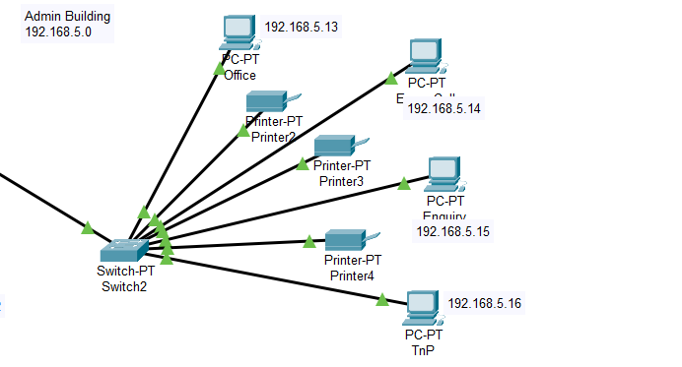

DEPARTMENT | COMPONENT | IP ADDRESS | DEFAULT GATEWAY | DNS SERVER | PRINTER  QUANTITY
Admin Building (192.168.5.0) | OFFICE | 192.168.5.13 | 192.168.5.1 | 192.168.1.3 | 3
Admin Building (192.168.5.0) | EXAM CELL | 192.168.5.14 | 192.168.5.1 | 192.168.1.3 | 3
Admin Building (192.168.5.0) | ENQUIRY | 192.168.5.15 | 192.168.5.1 | 192.168.1.3 | 3
Admin Building (192.168.5.0) | TnP | 192.168.5.16 | 192.168.5.1 | 192.168.1.3 | 3

Configuration Details:
Router1:
Router>enable
Router#
Router#configure terminal
Router(config)#interface Serial0/1/0
Router(config-if)#exit
Router(config)#router eigrp 1
Router(config-router)#network 192.168.1.0 255.255.255.0
Router(config-router)#network 192.168.4.0 255.255.255.0
Router(config-router)#network 201.151.12.0 255.255.255.0

Router(config-if)#exit
Router(config)#interface GigabitEthernet0/1
Router(config-if)#ip helper-address 192.168.1.2

Router2:
Router>enable
Router#
Router#configure terminal
Router(config)#interface Serial0/1/0
Router(config)#router eigrp 1
Router(config-router)#network 192.168.5.0 255.255.255.0
Router(config-router)#network 192.168.6.0 255.255.255.0
Router(config-router)#network 201.151.12.0 255.255.255.0
Router(config-router)#network 201.151.11.0 255.255.255.0
Router#
Router#configure terminal
Router(config)#interface GigabitEthernet0/0
Router(config-if)#ip helper-address 192.168.1.2
Router(config)#interface GigabitEthernet0/1
Router(config-if)#ip helper-address 192.168.1.2
Router3:
Router(config-if)#exit
Router(config)#interface Serial0/1/0
Router(config-if)#exit
Router(config)#router eigrp 1
Router(config-router)#network 192.168.3.0 255.255.255.0
Router(config-router)#network 192.168.2.0 255.255.255.0
Router(config-router)#network 201.151.11.0 255.255.255.0
Router>enable
Router#
Router#configure terminal
Router(config)#interface GigabitEthernet0/0
Router(config-if)#ip helper-address 192.168.1.2
Router(config)#interface GigabitEthernet0/1 Router(config-if)#ip helper-address 192.168.1.2
Network Plan:
The prototype of the DHCP Server network
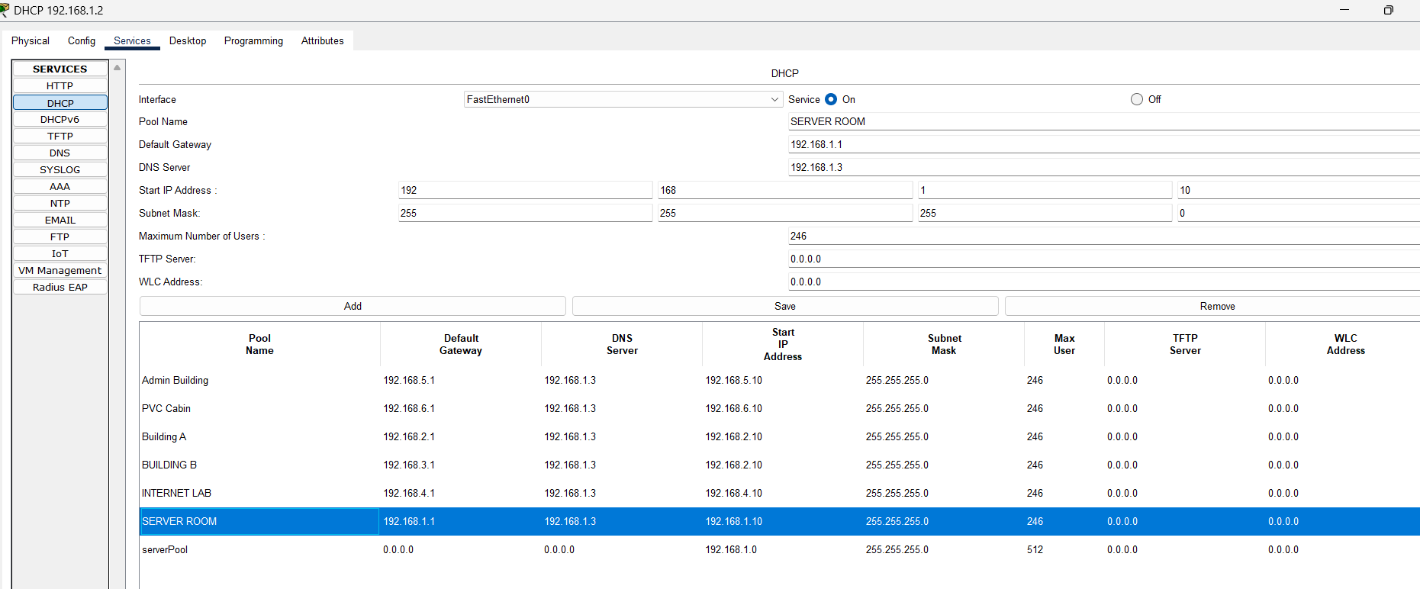
IP assigned with DHCP Server
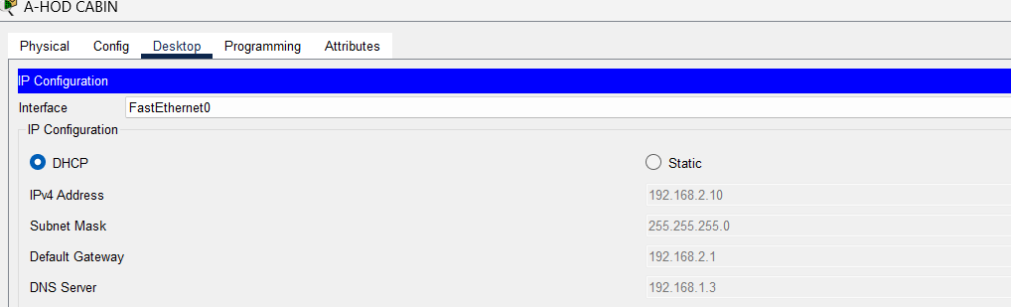
Testing ip config command prompt
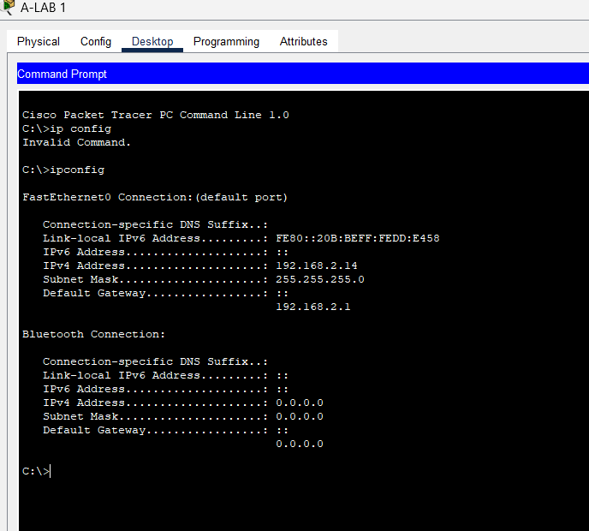
DNS Server
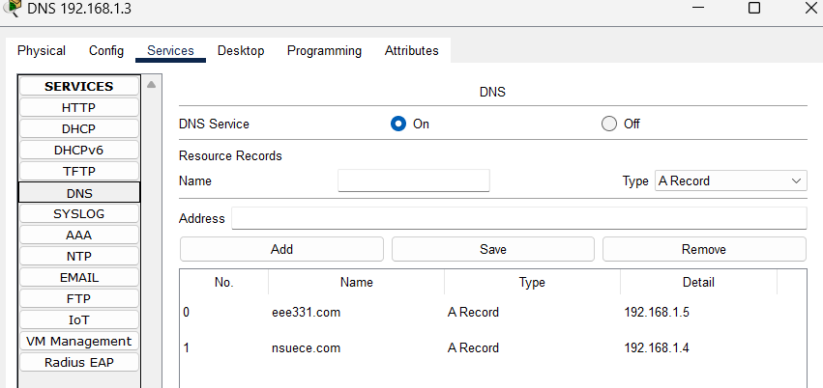
Testing Web Hosting
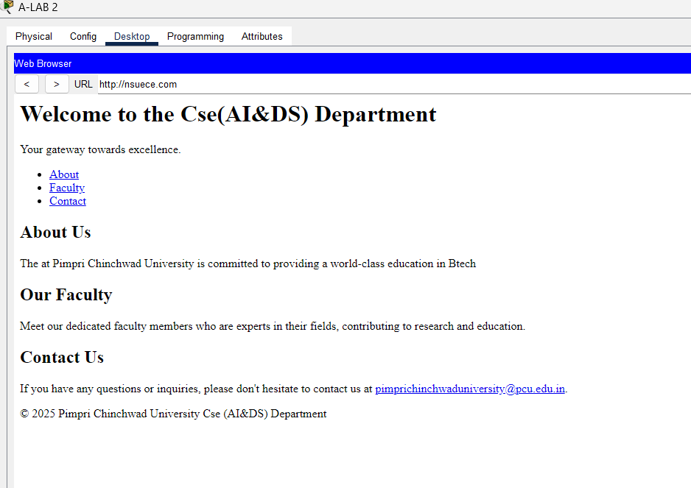
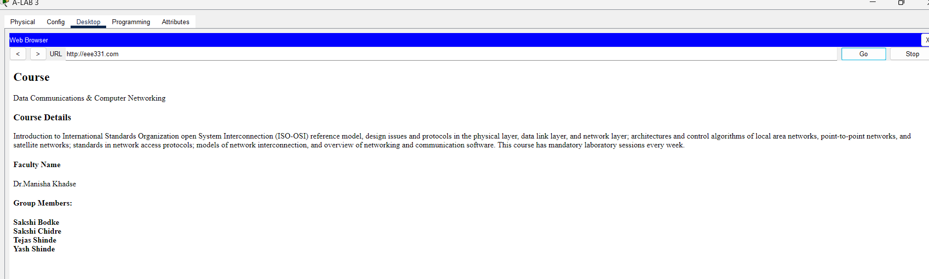
Packet Transfer
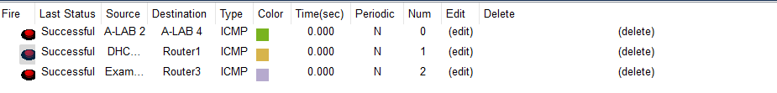
Advantages:
- Automated IP Management - DHCP eliminates manual configuration and IP conflicts
- Fast Convergence - EIGRP quickly adapts to network changes and link failures
- Reduced Network Traffic - Triggered updates instead of periodic broadcasts
- Easy Scalability - Simple to add new departments and devices
- Centralized Services - DNS, Web, and FTP servers accessible campus-wide
- Automatic Routing - No manual route configuration needed
- Cost-Effective - Reduces IT staff workload and administrative time
- Fault Tolerance - Automatic rerouting during link failures
- Seamless Communication - All departments interconnected efficiently
Disadvantages
- Single Point of Failure - DHCP server failure prevents new IP assignments
- Vendor Lock-in - EIGRP is Cisco proprietary, limiting hardware choices
- Security Gaps - No firewalls, authentication, or network segmentation implemented
- Complex Configuration - Requires trained personnel and careful setup
Results:
- Successful IP Allocation:
  - All devices received IP addresses automatically from the DHCP server (192.168.1.2).
  - The ipconfig command verified correct IP assignment across departments.
- Effective Routing:
  - The EIGRP protocol successfully established routes between all routers.
  - Fast convergence and minimal packet loss were observed.
- Service Accessibility:
  - The Web server and FTP server were accessible from all departments.
  - The DNS server correctly resolved hostnames.
- Network Performance:
  - Efficient packet delivery with reduced network traffic due to triggered updates in EIGRP.
  - Reliable communication between all connected departments.
References:
- Cisco Networking Academy – CCNA Routing and Switching: Scaling Networks
- Cisco Packet Tracer Documentation
- TutorialsPoint – EIGRP Configuration Guide

